Mrs. April Armstrong and Ms. Ayanna Dowell
Grade 5- Week of Aug. 20- 24, 2018 Volume 7, Issue 3

Reading
- Finding main ideas and details

Grammar
- 8 Parts of Speech unit- verbs

Math
- TLW read and write whole numbers.
- Hands-On Math Project
  - Students will create their own math manipulative, activity, or game. See rubric for details.
  - Due September 7th.

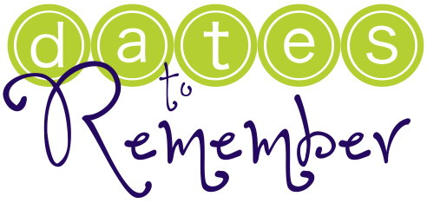

Aug 28 Fall Pictures
Aug 28 Fundraiser Kickoff
Aug 28 Boys Scout Parent
Meeting 6:30p
Sept 3 No School

Spelling
Test on Thursdays.
- emotion
- solution
- duration
- combination
- stationary
- adventure
- manufacture
- agriculture
- legislature
- outstanding
- proof
- understanding
- moisture
- annoy
- author
- auditorium
- awkward
- meadow
- coward
- culture

Science
- TLW describe the relationship between evidence and opinion.

Social Studies
- Chapter 1, Week 2 test Friday, Aug. 31st. Study guides will go home this week.
- Test Friday on state capitals adding Raleigh, North Carolina (NC) and Columbia, South Carolina (SC).

